CINNAMON WHIPPED CREAM

www.FronieMaeBakes.com

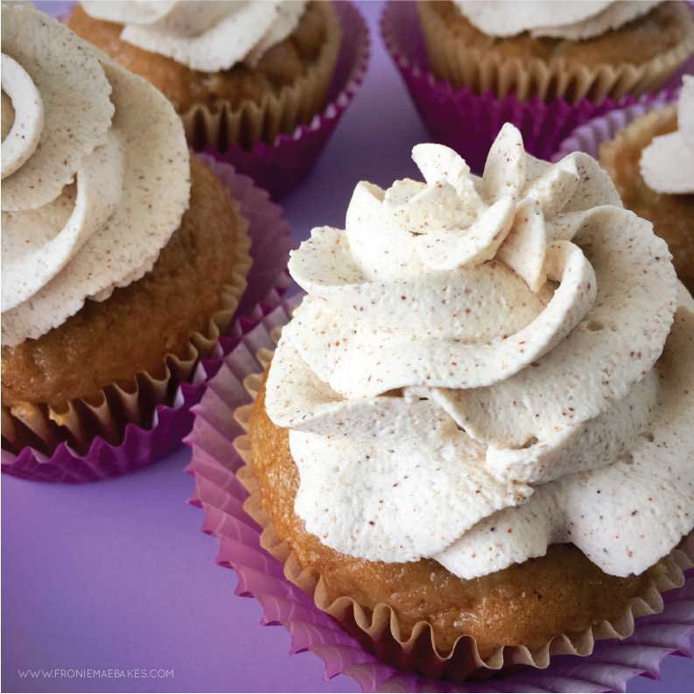
INGREDIENTS:
- 1.5 Cups of cold Whipping Cream
- 4 Tablespoons Granulated Sugar
- 1 Teaspoon Vanilla Extract
- 1 Teaspoon Ground Cinnamon

DIRECTIONS:
Step 1: Pour whipping cream, sugar, vanilla and cinnamon into a large bowl and whip together with an stand mixer using the whisk attachment OR an electric hand mixer on medium speed until soft peaks form.
Step 2: Fill a piping bag with whipped cream and decorate cupcakes or simply put a big dollop on top.
Refrigerate leftovers.

