Creamy Peanut Butter Frosting
www.FronieMaeBakes.com

Ingredients:
1 cup of room temperature butter
1 cup creamy peanut butter
1 cup marshmallow cream
2 cups powdered sugar
2 tablespoons milk

Directions:
Cream together butter, peanut butter and marshmallow cream.
Slowly add in powdered sugar until combined.
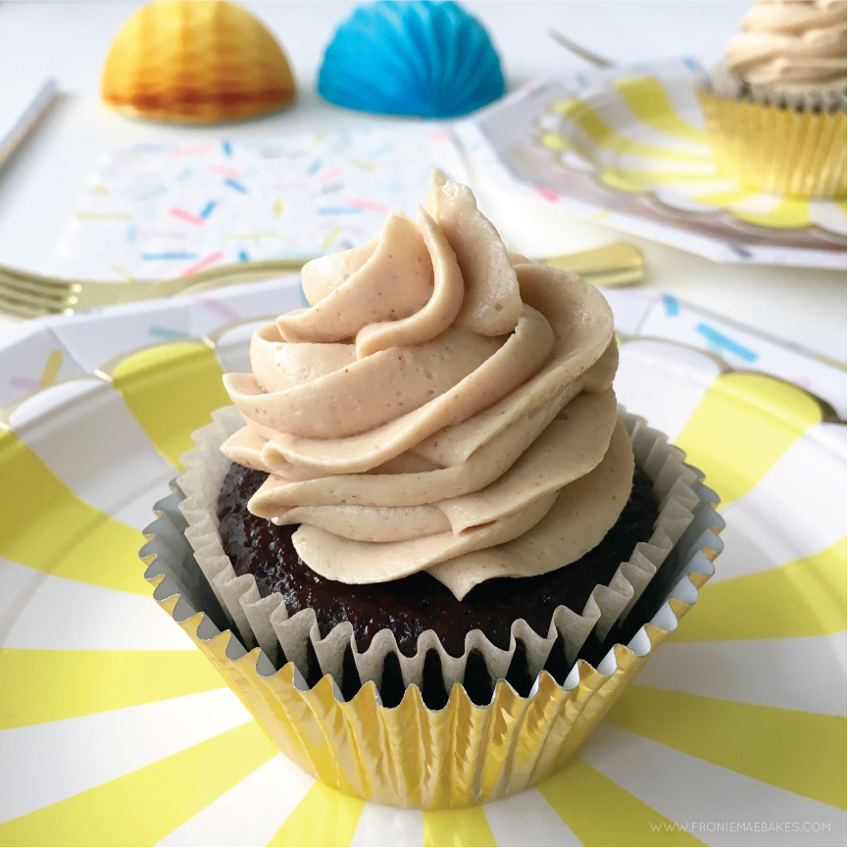
Add milk to loosen frosting.

