Marshmallow Buttercream with Salted Caramel Topping
www.FronieMaeBakes.com

Ingredients:

½ cup of softened butter (not melted)
2 cups powdered sugar
1-3 tablespoons of heavy whipping cream
1 teaspoon vanilla extract
1 container of marshmallow cream ( 7oz)
Caramel Sauce (for Sundays)
Freshly ground sea salt

Directions:

In a large mixing bowl, whip together butter, vanilla and marshmallow cream until smooth.
Slowly add in powdered sugar.
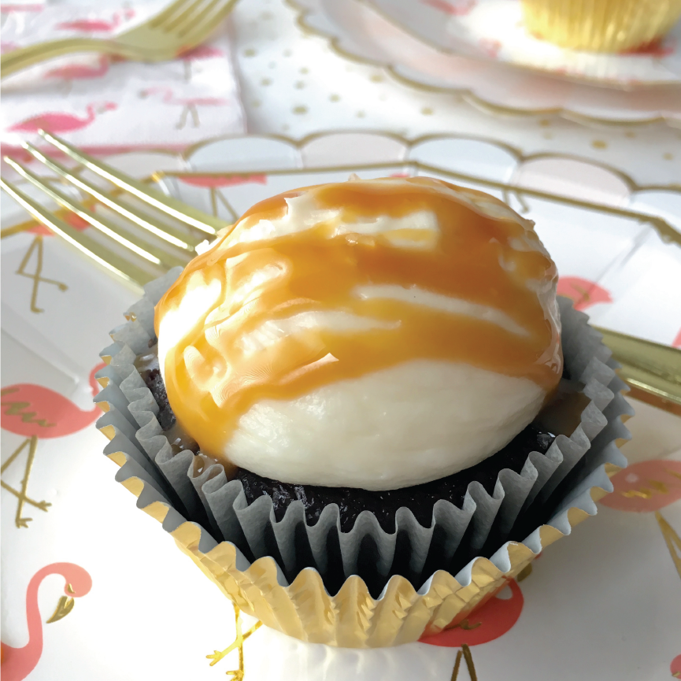
Add enough heavy whipping cream to loosen up your frosting to desired consistency.
Pipe frosting onto cooled cupcakes.
Drizzle caramel sauce over frosting
Top with a pinch of sea salt

